Infopack
“Europe make it better”

When: 8-16.03.2019

Where: Poronin, Poland, Tatra mountains
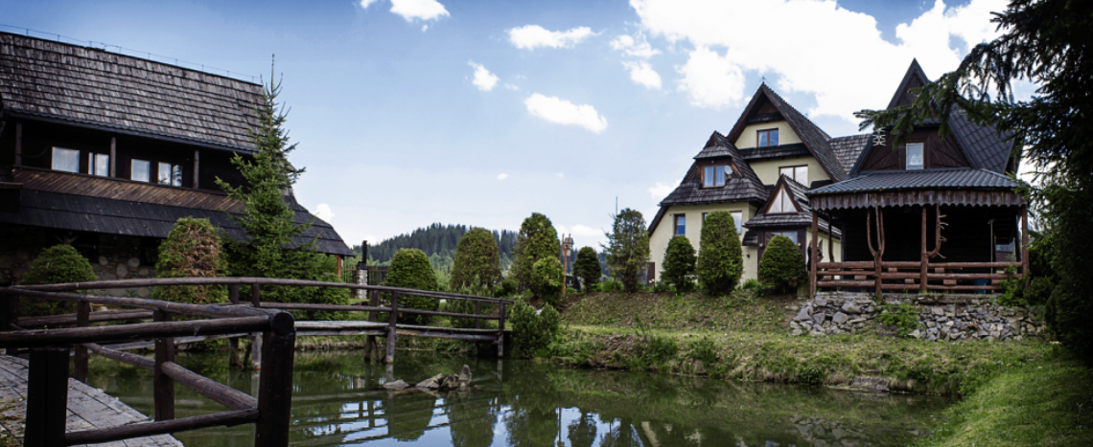

About the project: The aim of our project implemented under Action 1 is to expand knowledge on the European Union, the principles of its functioning, increase the level of civic activity, and build European awareness. The participants of the project are youth and leaders from 4 countries Lithuania, Czech Republic, Spain and Poland - in total 40 people. Methods of work used during the project - brainstorming, workshops, discussions, meetings, presentations or methods of informal education will enable us to achieve the goals we set. The project is based on active partnership and active participation of participants at all stages of the project. Our project raises the level of knowledge on the functioning of the European community, encourages civic participation, and increases interest in European affairs. The long-term effect of our project is to strengthen in us the values on which the European community is based - tolerance, solidarity, respect for the dignity of the human person, freedom, democracy and equality. We planned the exchange activities on 8-16 of March in Poronin.

Participating organizations:
- Europejskie Centrum Mlodziezy Poland
- Educadaje Spain
- BRNO FOR YOU ZS Czech Republic
- Asociacija "Tavo Europa" Lithuania

Who we are looking for:
- National team: 10 people per each country including 1 leader
(9 participants plus 1 leader)
- Age of participants: 16-18
The leader and one participate should also participate in the preparatory meeting in Poland. The preparatory meeting will be 16-18 February 2019 (1 leader, 1 participant).

Accommodation: www.austryjok.com

WHAT TO BRING:
- Comfortable clothes and shoes for workshops which we will organize in indoor and outdoor atmosphere depending on weather, slippers.
- Camera and laptop also would be very useful during main activities.
- Photos will be taken during project by our team as well and at the end of the project we will share on-line with all partner organizations before departure.
- Traditional food, drink and souvenirs for intercultural evenings activities.

INSURANCE & HEALTH ISSUES: The participants are themselves responsible to get a insurance. If anyone who uses medicine should bring with themselves. We don’t give any medicines and we don’t cover insurance fees.

FOOD: If there’s any person with special diet/ allergies, please inform us about this.
It is especially important for us to know about diets/allergies/special needs.

